Project’s objective: “*To receive funding, the project must meet or exceed an initial goal, so many organizations dedicate considerable resources looking through old projects in an attempt to discover “the trick” to finding success*.”

1. **Given the provided data, what are three conclusions that we can draw about crowdfunding campaigns?**
2. Based on Pivot table 1 on the spreadsheet, the crowdfunding campaigns achieved a 56.5% success rate; 36% of the campaigns failed, 5.7% were canceled, and only 1.4% were live. The highest number of crowdfunding activities occurred within the theater category, although this category was successful only 187/344 times (54% success rate). Furthermore, theater’s success rate was lower than other activities, such as technology which was successful 64/96 times (67%), or journalism, which had the lowest number of crowdfunding activities (4/4) but a perfect success rate.
3. Based on Pivot table 2 on the spreadsheet, the highest number of crowdfunding activities, or 34.4% of the total, were in theater plays, and the lowest involved world music at 0.3%. However, the three world music crowdfunding activities achieved a 100% success rate, while the 344 theater plays were only successful 54% of the time. Therefore, in the future, the organizers may consider borrowing best practices from world music and applying them to the theater category for an increased success rate. Furthermore, they could slightly increase the fundraising goals for world music in the future since they exceeded their fundraising goals by 56% in that subcategory.
4. Based on Pivot table 3 on the spreadsheet, July was the most successful month for fundraising activities, and August was the least successful, with the highest number of failures and cancellations.
5. **What are some limitations of this dataset?**
6. The launch and deadline dates were in UNIX format and needed to be converted into a date format in Excel.
7. The categories and subcategories were initially grouped and needed to be separated into two distinct fields.
8. The dollar amounts for the goals and pledges were in a generic format and needed to be reformatted into currency.
9. The four types of outcomes are in a nominal data format and would have to be transformed into a numerical form for optimal data analysis.
10. 77% of the observations (ids) were from the United States, which could impact the reliability of the outcome of this project with such a high percentage of the sample size being concentrated in one location when a total of 7 countries were included in this project.
11. **What are some other possible tables and/or graphs that we could create, and what additional value would they provide?**
12. A table or pie chart could be helpful to determine the percentage funded by country. Crowdfunding activities were more successful in the United States (US) and least successful in China (CH). In this case, a pie chart would provide a visual snapshot of the success of the campaigns per country. In the case of this project, this means that future crowdfunding campaigns in the United States are projected to be as successful as the ones done this year. Furthermore, based on the graph, the United States can provide best practices that may be applied to other countries efforts to raise funds.



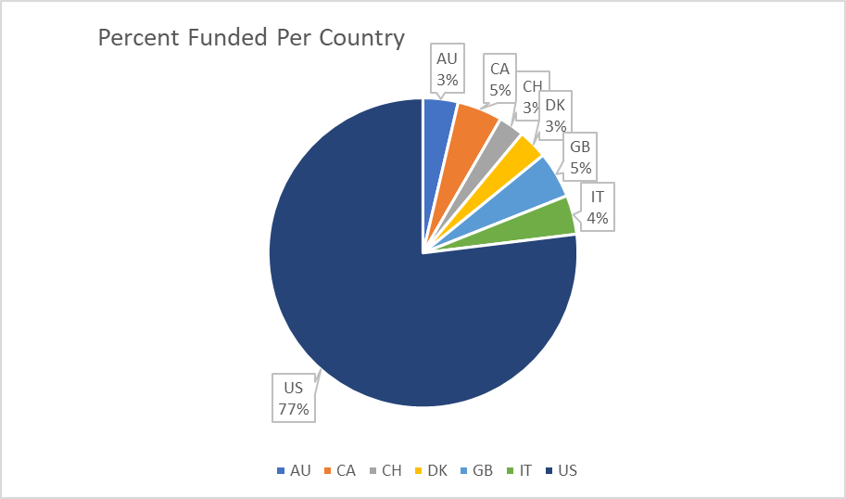

1. Another helpful graph could compare the difference between goals and amounts pledged by a country to determine expectations and success rates. Some countries may set lofty crowdfunding goals and only reach a portion of theirs, while others may have exceeded their goals and could raise them for future campaigns. For example, Canada (CA), Italy (IT), and Great Britain (GB) exceeded their crowdfunding goals by 18%, 17%, and 3%, respectively. However, the United States, with the most significant success in crowdfunding, fell short of its overall goal by 5%. A Clustered Column Graph would provide a good visual for this observation.



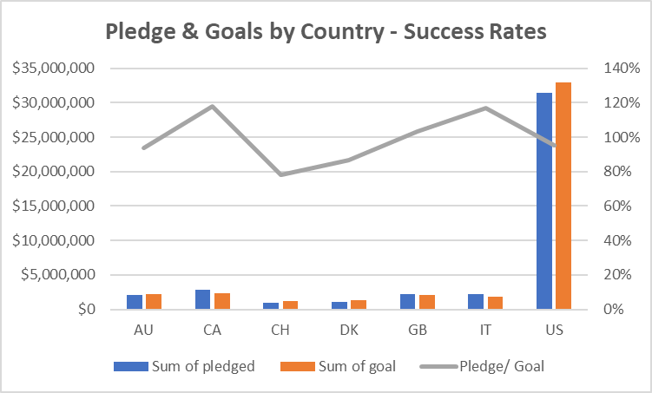

1. Lastly, another helpful observation would be determining how close the pledge amounts were to the goal for each crowdfunding category. This observation will help determine whether the organizers should adjust their goals for future campaigns. For categories that exceeded 100%, future goals could be increased; for those under 100%, the goals could remain the same, and future crowdfunding strategies could also be revised. A simple bar graph or a more detailed clustered column graph would work in this case - see below:



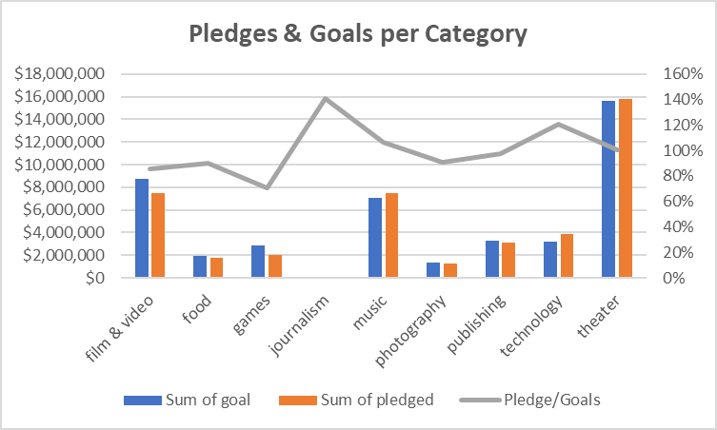

**Statistical Analysis**

1. **Use your data to determine whether the mean or the median better summarizes the data.**

For successful and failed crowdfunding outcomes, the mean better summarizes the data related to the backers' count. The means of 851.1 and 585.6 for successful and failed outcomes, respectively, constitute a better gauge of the range of the number of backers than the respective medians of 201 and 114.5.

1. **Use your data to determine if there is more variability with successful or unsuccessful campaigns. Does this make sense? Why or why not?**

The successful campaigns display more significant variability than the unsuccessful ones, with respective sample variances of 1606217 and 924113.455. This makes sense because the data for the successful campaigns are more spread out than unsuccessful campaigns as indicated by the kurtosis for successful campaigns of 4.96 being lower than that of unsuccessful campaigns being 8.80.